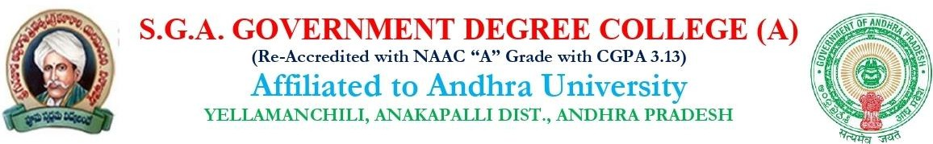

TIME TABLE FOR SCIENCES(2025-2026)
SEM I,III,V

WEAK | SEM | 1  (10.00-  10.50) | 2  (10.50-  11.40) | 3  (11.40-  12.30) | 4  (12.30-  1.20) |  | 5  (2.20-  3.10) | 6  (3.10-  4.00) | 7  (4-5PM)
MON | 1ST |  |  |  |  | L  U  N  C  H |  |  | PGCET/  JKC/U.P
MON | 3RD | P-5 | P-6 | P.M | P-8 | L  U  N  C  H | I.C.T | ENG | PGCET/  JKC/U.P
MON | 5TH | P-13 | P-5 | P-14 | P-6 | L  U  N  C  H | <-------p-12 → |  | PGCET/  JKC/U.P
TUE | 1ST |  |  |  |  | L  U  N  C  H |  |  | PGCET/  JKC/U.P
TUE | 3RD | ENG | P-7 | <-------P-5 🡪 |  | L  U  N  C  H | P-6 | TEL/HIN | PGCET/  JKC/U.P
TUE | 5TH | P-12 | P-14 | P-5 | P-15 | L  U  N  C  H | ←----p-13---→ |  | PGCET/  JKC/U.P
WED | 1ST |  |  |  |  | L  U  N  C  H |  |  | PGCET/  JKC/U.P
WED | 3RD | P-5 | P-2 | <-------P-7 🡪 |  | L  U  N  C  H | P-8 | ENG | PGCET/  JKC/U.P
WED | 5TH | P-15 | P-12 | P-5 | P-6 | L  U  N  C  H | ←------p-14---→ |  | PGCET/  JKC/U.P

THU | 1ST |  |  |  |  | B  R  E  A  K |  |  | PGCET/  JKC/U.P
THU | 3RD | P-2 | <--------P-6 🡪 |  | P-8 | B  R  E  A  K | P-5 | TEL/HIN | PGCET/  JKC/U.P
THU | 5TH | P-12 | P-6 | P-13 | P-5  (MAT) | B  R  E  A  K | ←------p-15 → |  | PGCET/  JKC/U.P
FRI | 1ST |  |  |  |  | B  R  E  A  K |  |  | PGCET/  JKC/U.P
FRI | 3RD | P-7 | <--------P-8 🡪 |  | I.C.T | B  R  E  A  K | P-2 | TEL/HIN | PGCET/  JKC/U.P
FRI | 5TH | P-13 | P-15 | P-5(MAT) | P -6  (MAT) | B  R  E  A  K | ←-----p-5 → |  | PGCET/  JKC/U.P
SAT | 1ST |  |  |  |  | B  R  E  A  K |  |  | PGCET/  JKC/U.P
SAT | 3RD | <------P-2 🡪  P-2(MAT) |  | P-6 | P-7 | B  R  E  A  K | P.M | P-2  (MAT) | PGCET/  JKC/U.P
SAT | 5TH |  | P-14 |  | P-6  (MAT) | B  R  E  A  K | ←--------P-6------  → |  | PGCET/  JKC/U.P

SEM-3: MAJOR PAPERS(P-5,P-6,P-7,P-8) MINOR PAPERS(P-2)
SEM-5: MAJOR PAPERS(P-12,P-13,P-14,P-15) MINOR PAPERS(P-5,P-6)

